**Using Server Manager (UI):**

In order to make the windows server 2012 domain controller we will install ADDS (Active Directory Domain Services) role from the server manager

1. Open the **server manager** from windows start menu
2. Click on Add roles and features
3. On **Installation Type** page, select the first option “**Role-based or Feature-based Installation**“
4. On the “**Server Selection**” Page, **select a server from the server pool**and click next
5. To install AD DS, select **Active Directory Domain Services** in turn it will pop-up to add other AD DS related tools. Click on **Add Features**
6. On the “**Select Features**” Page, **Group Policy Management feature** automatically installed during the promotion. Click next
7. On the “Active Directory Domain Services” page, it gives basic information about AD DS. Click Next
8. After clicking “**Install**” the selected role binaries will be installed on the server

 After “Active Directory Domain Services” role binaries have been installed and now it is time to promote the server to a Domain Controller

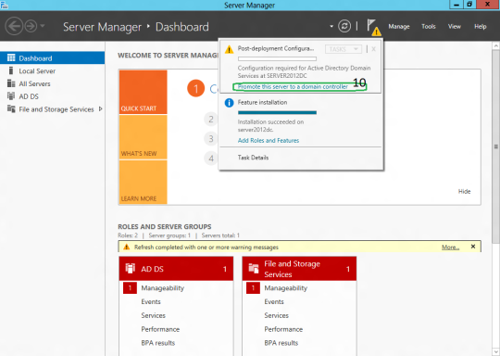

### **Promoting Windows 2012 Server to Domain Controller**

To create a new AD forest called “**CORECOMPETE.COM**”,(It should be in upper case) select add a new forest

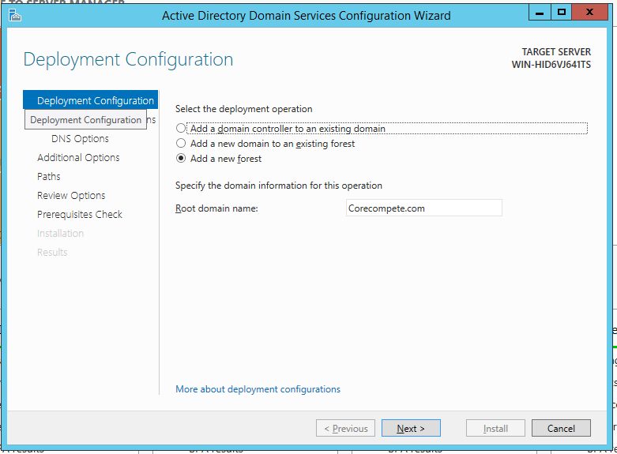

Specify the FFL, DFL, whether or not it should be a DNS Server and also the DSRM administrator password

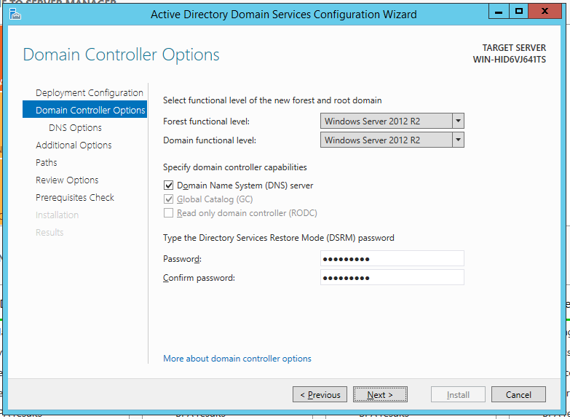

**DNS delegation warning:**

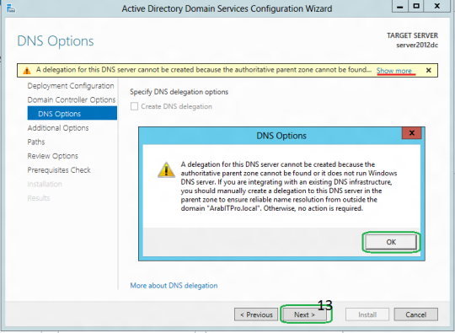

**Checks the NetBIOS name already assigned:**

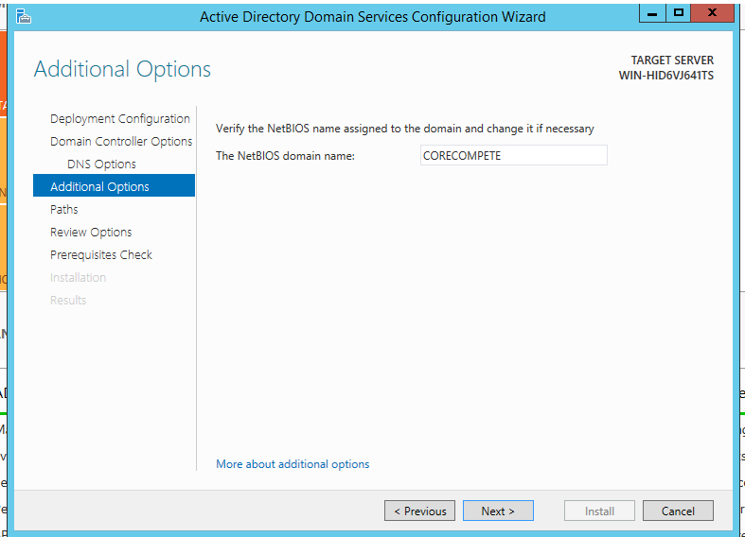

* **Specify the location of the AD related folders (keep it default) and then click next**
* **Summary Of All Installation Options/Selections**
* Before the actual install of AD, all prerequisites are checked. If All prerequisite checks are passed successfully then click**Install**

After the promotion of the server to a DC finished server restart automatically.

Once the server is booted and you logon to it, click on Server Manager | Tools , will notice that following have been installed:

* Active Directory Administrative Center
* Active Directory Domains and Trusts
* Active Directory Module for Windows PowerShell
* Active Directory Sites and Services
* Active Directory Users and Computers
* ADSI Edit
* DNS
* Group Policy Management

